|  |
| --- |
|  |
| Capstone Project Document |

**BOOKAHOLIC SOCIAL NETWORK**

Report #2 – Class Design

|  |  |  |
| --- | --- | --- |
| **Bookaholic Social Network** | | |
| **Group Members** | Phạm Thị Huyền | SE03416 |
| Thái Thị Cẩm Vân | SE03409 |
| Vũ Hải Đăng | SE03380 |
| Nguyễn Thị Hải Yến | SE03171 |
| Chu Minh Hải | SE03143 |
| **Supervisor** | Mr. Nguyễn Văn Sang | |
| **Project code** | BSN | |

**- Hanoi, 10/2016 -**

# SIGNATURE PAGE

AUTHOR: Phạm Thị Huyền --/--/2016

Project manager

REVIEWERS: --/--/2016

Team member

APPROVAL: Nguyễn Văn Sang --/--/2016

Supervisor

Record of change

*A - Added M - Modified D – Deleted

|  |  |  |  |  |  |
| --- | --- | --- | --- | --- | --- |
| Effective Date | Changed Item | A,M,D | Change Description | Reason for Change | Rev. Number |
|  |  |  |  |  |  |
|  |  |  |  |  |  |
|  |  |  |  |  |  |

TABLE CONTENTS

SIGNATURE PAGE 1

Introduction 3

1.1 Purpose 3

1.2 Definitions, Acronyms and Abbreviations 3

2 Package 3

2.1 Package Diagram 3

2.2 Package Description 4

2.2.1 Model 4

3 Function 4

# Introduction

## Purpose

## Definitions, Acronyms and Abbreviations

|  |  |  |
| --- | --- | --- |
| Abbreviations | Description | Note |
| BSN | Bookaholic Social Network |  |
|  |  |  |

1. Definitions, Acronyms and Abbreviations

# Package

## Package Diagram

1. Package Diagram

## Package Description

### Model

# Function

## Guest Module

### Register

#### Class diagram

#### Sequence diagram

##### Register for a normal account

##### Register for an author account

## Reader/Author Module

### Account

#### Class diagram

#### Sequence diagram

##### Login

##### Logout

##### Edit personal information

##### Edit avatar and cover photo

##### Reset password

### Post

#### Class diagram

#### Sequence diagram

##### Create a post

##### Edit a post

##### Delete a post

##### Like a post

##### Unlike a post

##### Comment on a post

##### Delete a comment

### Interaction

#### Class diagram

#### Sequence diagram

##### Follow user account

##### Report user account

##### Send join-group request

##### Leave a group

##### Report a group

##### Get Notification

### Group

#### Class diagram

#### Sequence diagram

##### Create a group

##### Edit group information

##### Edit group's avatar/cover photo

##### Add new members

##### Accept join-group request

##### Set group's admin

##### Remove a member

##### Create a group post

##### Like a group post

##### Edit a group post

##### Delete a group post

##### Comment on a group post

##### Delete comment on a group post

### Book

#### Class diagram

#### Sequence diagram

##### Rate a book

##### Comment on a book

##### View a book's details

##### Search book/author/other account/group

##### View suggested books/authors

## Admin Module

### User Accounts Management

#### Class diagram

#### Sequence diagram

##### Search user

##### Ban user

##### Unban user

##### Decline request about reporting an account

##### Accept request about creating author account

##### Decline request about creating author account

### Groups Management

#### Class diagram

#### Sequence diagram

##### Band a group

##### Unban a group

##### Decline request about reporting a group

### Books Management

#### Class diagram

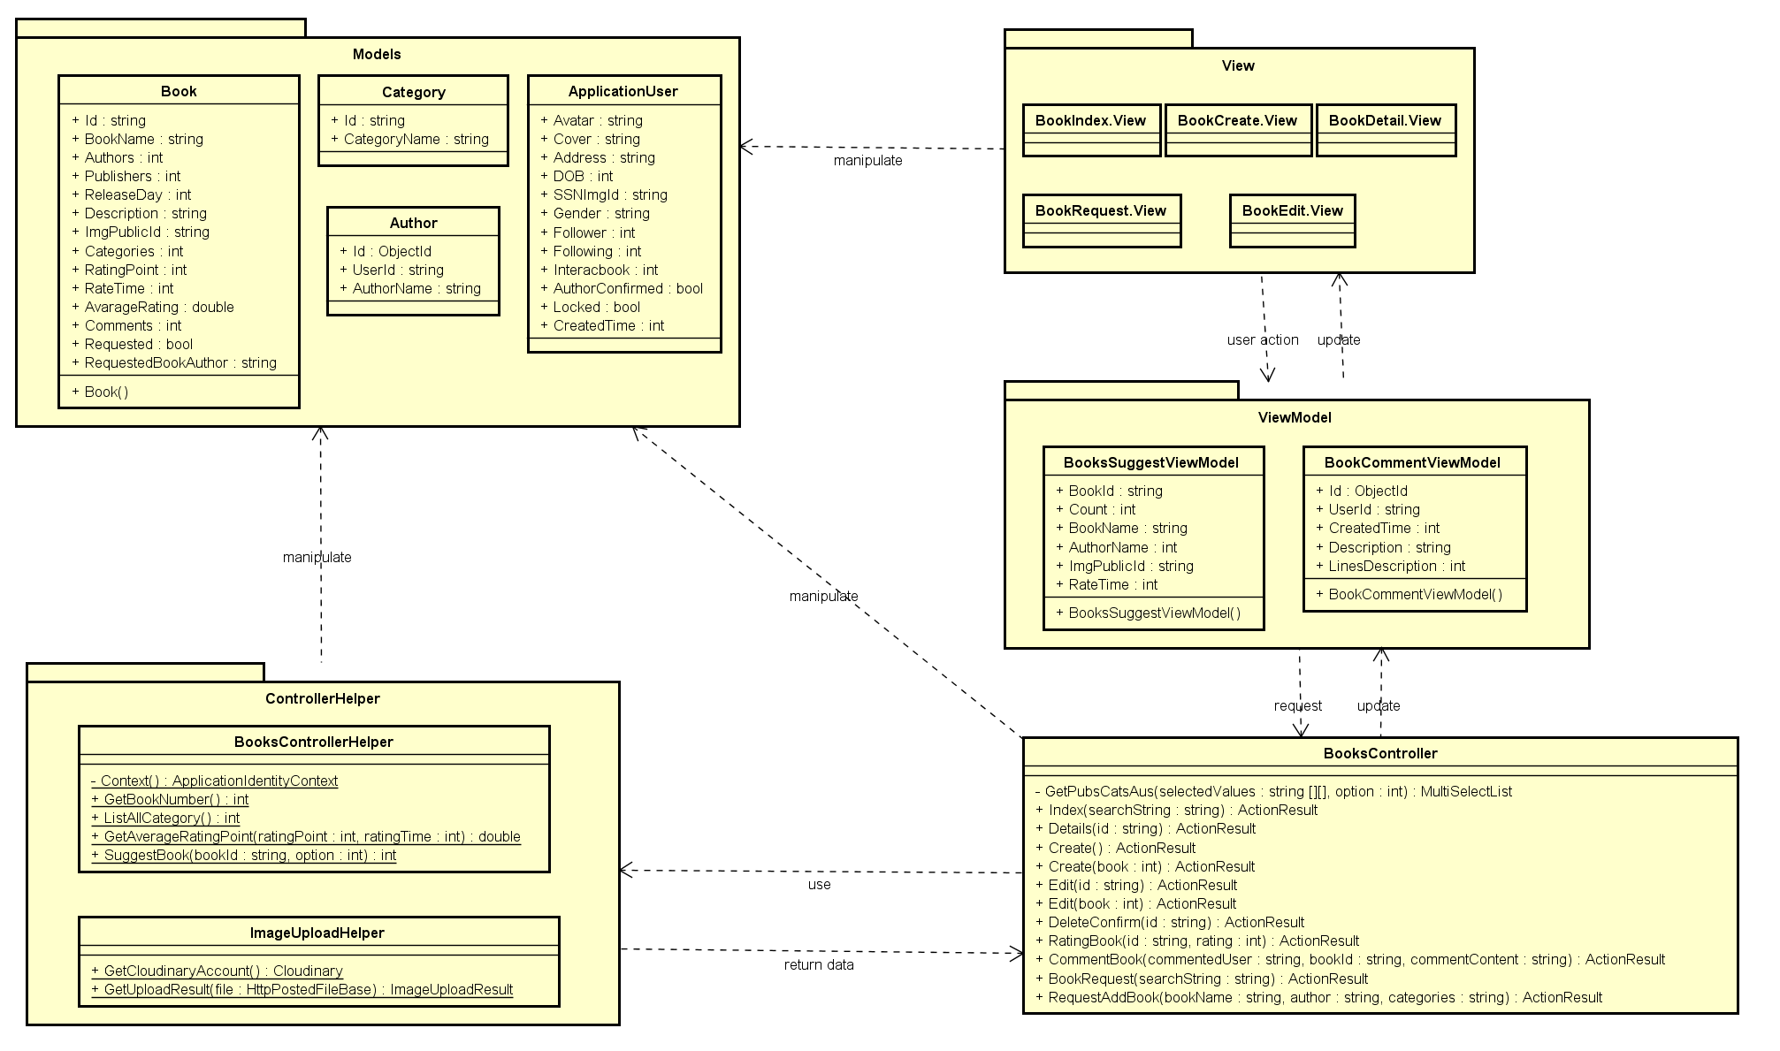

Figure ‑: Book Management Class Diagram

#### Sequence diagram

##### Add a new book

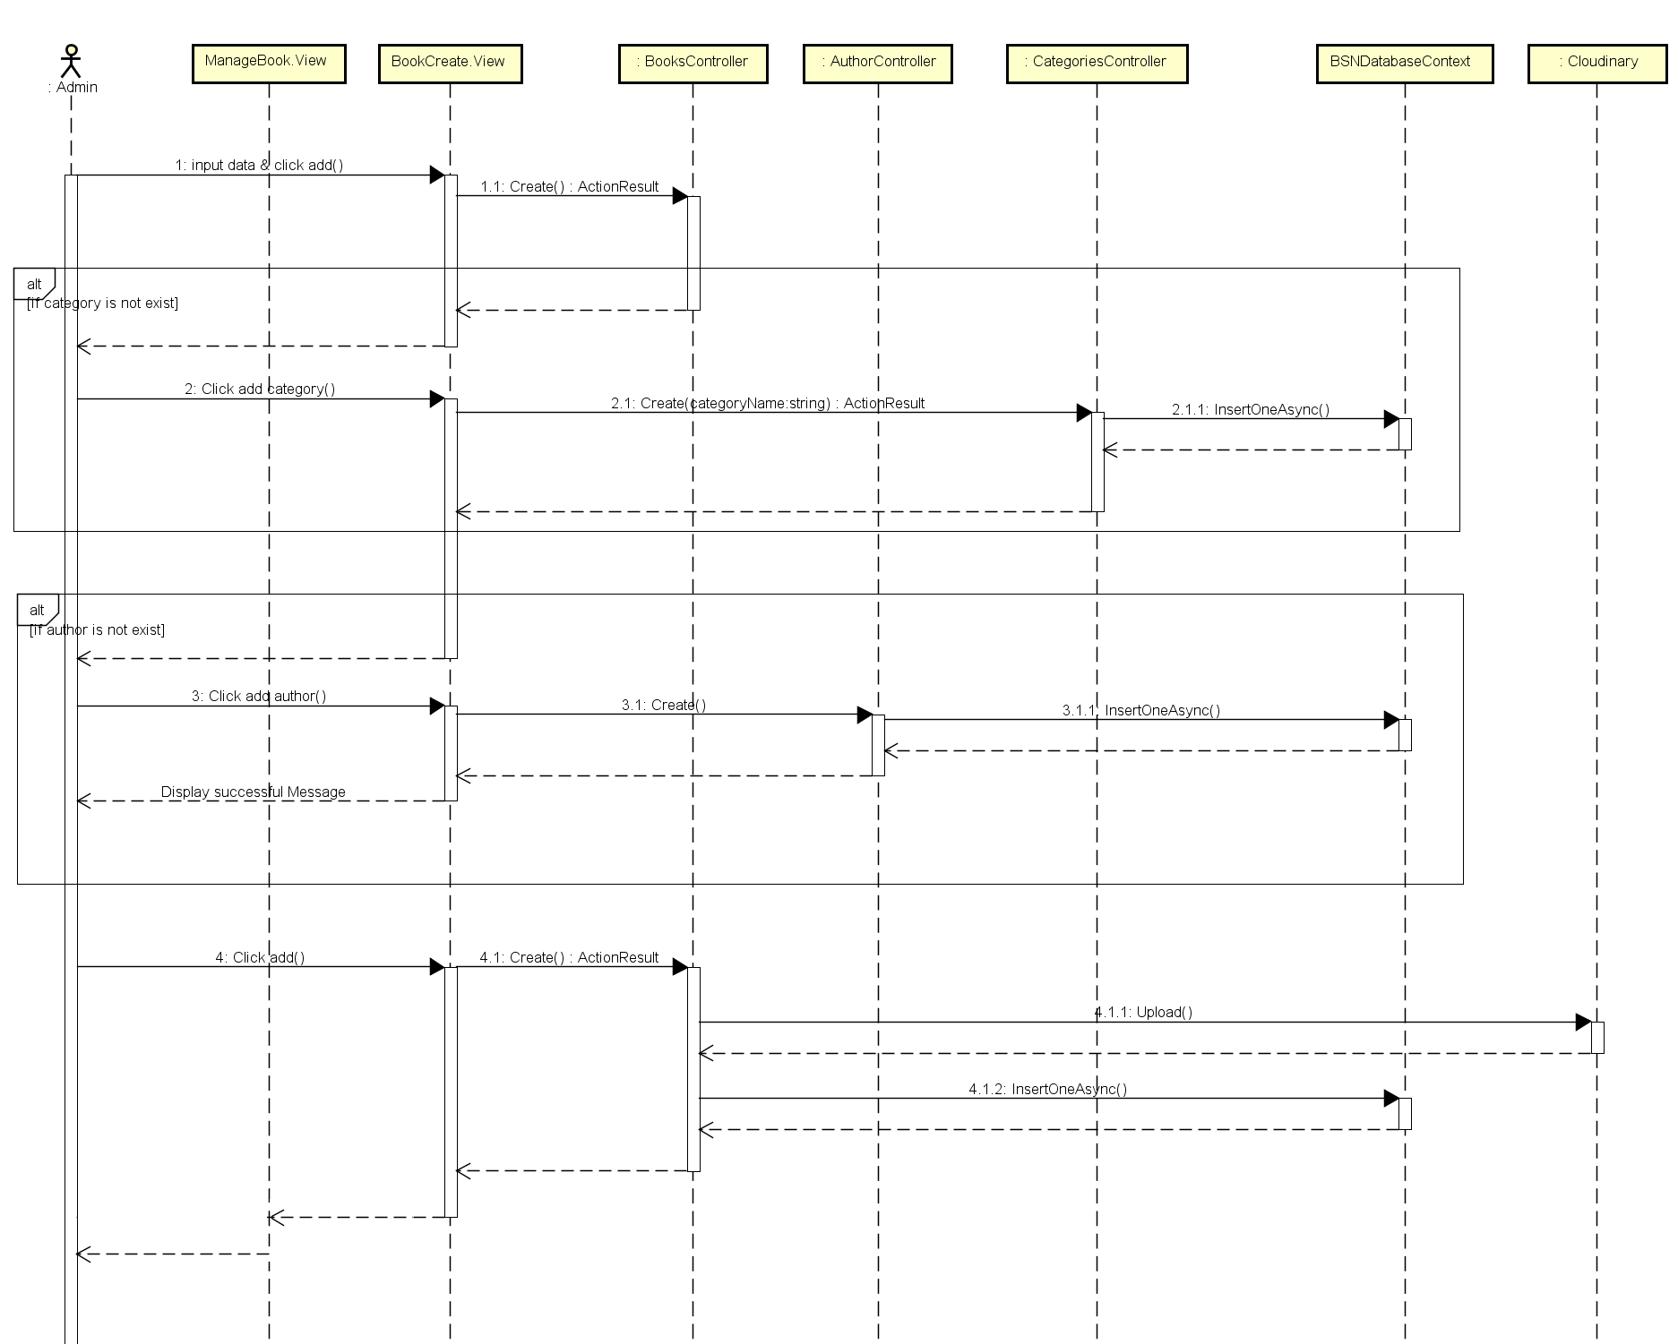

Figure ‑: Add Book Sequence Diagram

##### Add a new Category

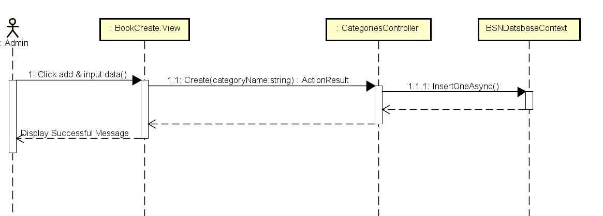

Figure ‑: Add Category Sequence Diagram

##### Add an author

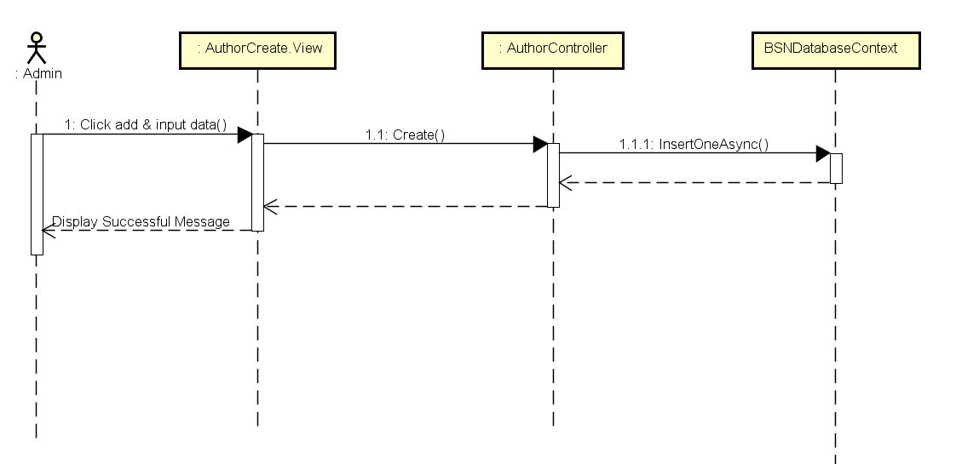

Figure ‑: Add Author Sequence Diagram

##### Edit book's information

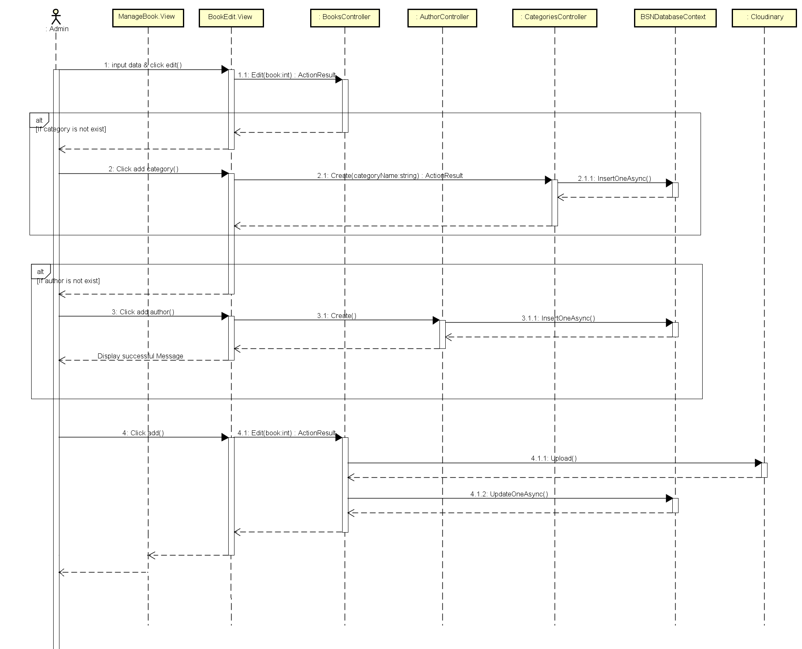

Figure ‑: Edit Book Sequence Diagram

##### Accept add-book request

##### Decline add-book request

### Sliders Management

#### Class diagram

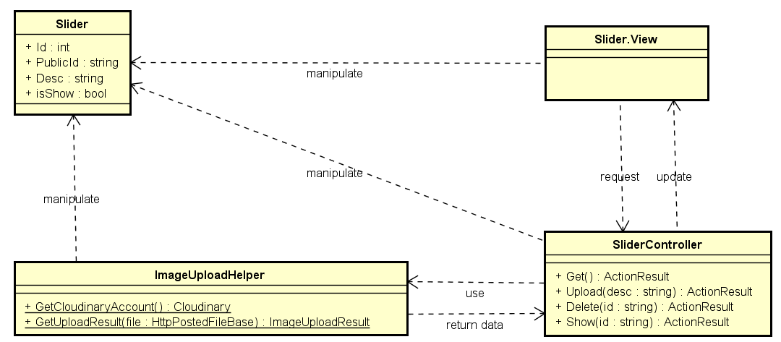

Figure ‑: Slider Management Class Diagram

#### Sequence diagram

##### Add a slider

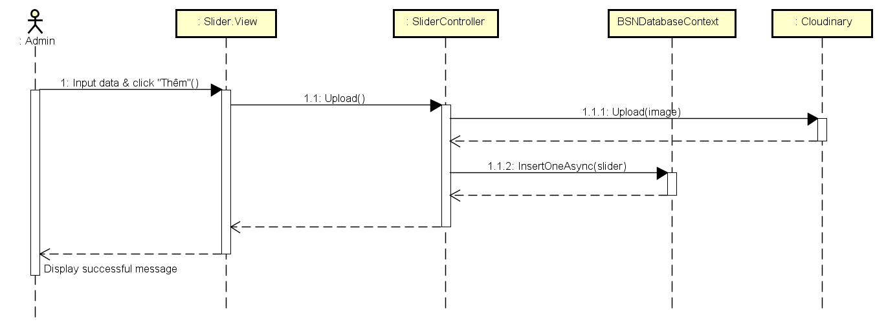

Figure ‑: Add Slider Sequence Diagram

##### Delete a slider

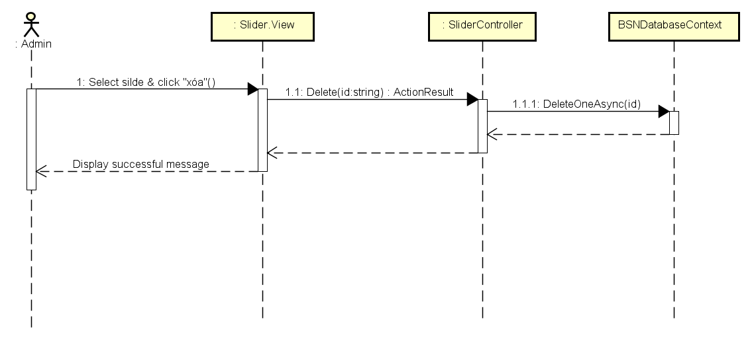

Figure ‑: Delete Slider Sequence Diagram

##### Active/de-active a slider

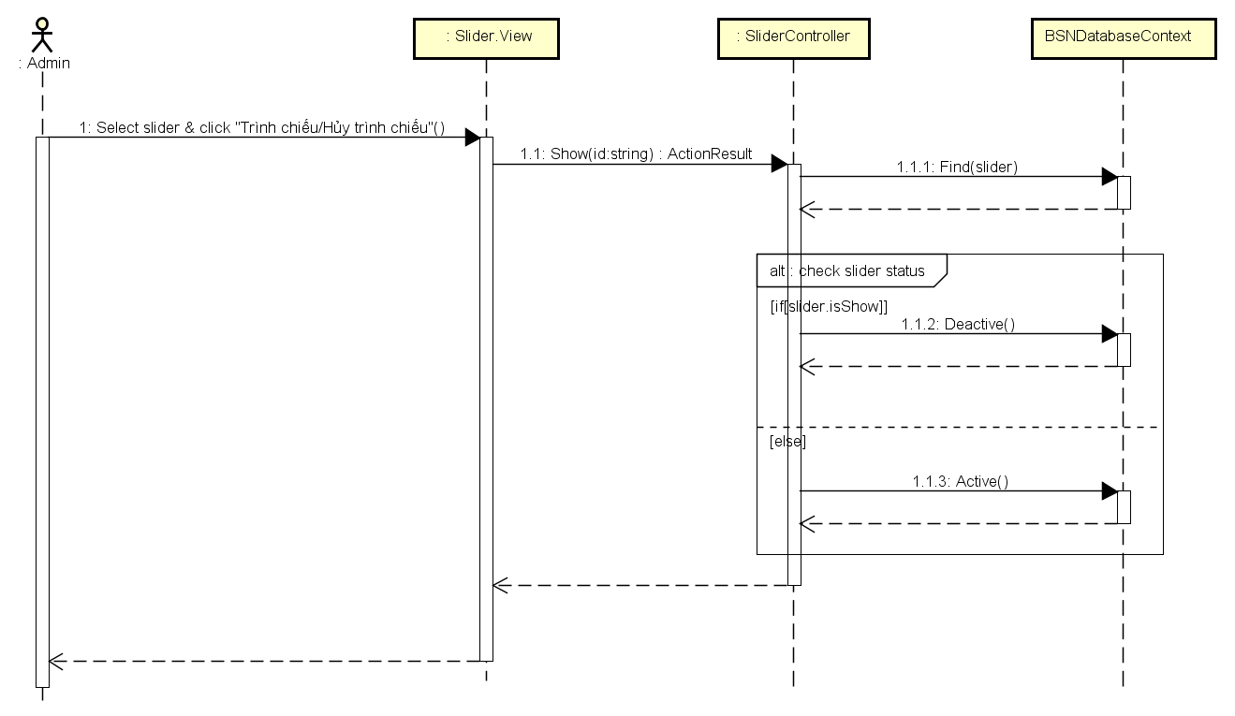

Figure ‑: Active/De-active Slider Sequence Diagram

##### Show sliders

### Publishers Management

#### Class diagram

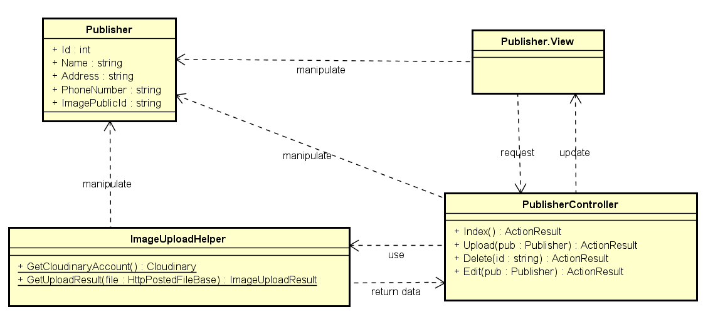

Figure ‑: Publisher Management

#### Sequence diagram

##### Add a new publisher

##### Edit publisher' information

##### Delete a publisher

### Statistics